Baseline

Baseline method(Naive Mean Method) is simplistic as it utilized a quite general method which didn’t take into consideration individual difference. Then comes our brainstorming about how to extract features to fully use the data.

Feature Extraction
Key point Box matching method
Assumption: In predicting problem for one specific key point,we should highlight those pixels that are around that key point.
Motivated by this assumption, we design our new strategy of using “Image Box”: Instead of utilizing all information of a picture, we use small box to extract out matching area in picture for one specific key point.This method is a two-step strategy: first calculte a mean key point and pick the bestmatch of the mean key point to all possible small box in a one test data.
To further illustrate this method, Let’s first focus on one single key point, say: nose_tip.
For each picture in training dataset, we extract a 21*21 (after trial and error) square box around nose_tip.After we got all 6049 21*21 boxes, we calcate the average of all these 6049 matrices.
The result is presented below(left 1:Mean Nose_tip),see how much it looks like a nose!

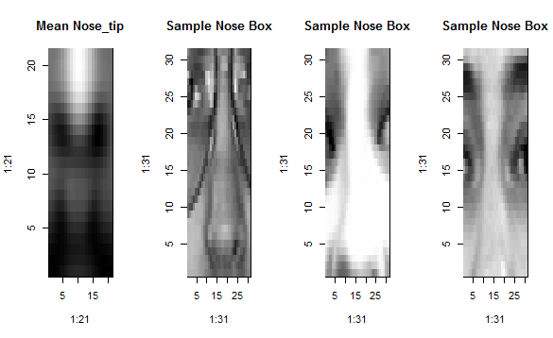
Now we can use this Mean Nose_tip box to “search” for the same keypoint in the test images.
Given a test image we need to try all its possible 21*21 boxes, and see which one bestmatches the mean-nose box. How to determine such bestmatch? Our measure is correlation with the mean-nose box:
The coordinate with the highest score of correlation with that mean-nose box is considered to be our predicted location of nose.

We can easily apply the same idea to other key points.

Compared with Naive Mean mehod baseline, this feature box extraction method achieves a prediction error score of 3.702. It’s an improvenmt and the result makes sense.
Combine PCA with KNN
Assumption: If two pictures are “close” enough, then the location of key points of the two faces are very similar. Inspired by this idea, we would like to detect the “nearest neighbour” of each test picture in the training datasets,and immediately assign the coordinates of that nearest training picture to the test picture.
However, it comes the problem about how to measure such closeness.If we choose Euclid Distance measure, there still exists severe problem about “huge”data. Here we have altogether 7049 pictures, each represented by a 96*96 matrix(or a vector with length 96*96). To calculate distance matrix for this dataset with such huge number of dimensions is a disaster.
Dimension reduction is something covered in basic machine learning topic. We immediately turn to PCA(Principle Component Analysis)technique.
To do PCA on a 7049*(96*96) matrix still suffer typical“n<<p”problem. To solve this, we apply a simply strategy to compress each picture from 96*96 to 24*24. The strategy computes all average for each 4*4 box in original picture and replace initial 16 pixel with one value. This try ends with a very satisfying result. After all, we are trying to reduce dimension from 96*96 to something like 30 or less, this initial step with 24*24 is reasonable.
Do PCA on training set and use the first 30 scores as a vector to represent data.Specically, that means creating the mean face from the training set, subtracting the mean face, and running prcomp() on the resulting image matrix. Project your testing data onto the first 30 loadings so that it is also represented by the first 30 scores. The following is the “Eigenfaces”(eigenvalues)
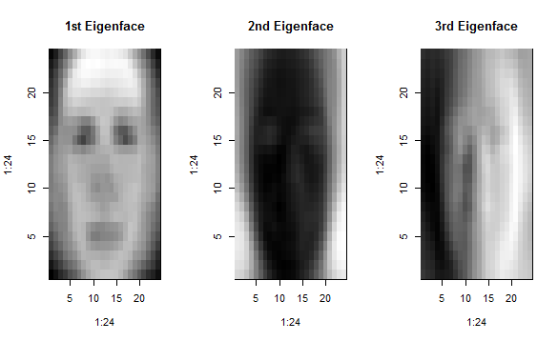

Use 1NN classication in the space of the firrst 30 scores to identify the subject for each testing observation.
Result:
Let’s look at some of the matched pairs given by our PCA&1NN method.
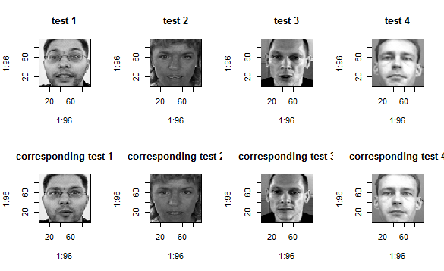

Visulization indicates that our combined method works perfectly as it can exactly picks out the same person in training data corresponding to test data! We have gain some very interesting insight about this dataset: This dataset might be originially from so-called “facial detection” problem, which is interested in identifying the same person’s picture in training data.We can definitely say that our method did a very good job in this problem. The difference of two pictures are merely slight different pose of that person or different angle of camera.It seems like magic and we are very confident that PCA retain very useful information of the initial data so that the two corresponding pictures are really close enough.

However, our main concern lies in whether this method has good performace of our interested question in terms of prediction error? The answer is YES. Our test error has a bad performance of 5.654, which shows an obvious improvement compared with baseline though not good “enough”. However, we also notice that the error in the first 4 test data is 1.531, 1.370, 1.684 and 1.193 which is quite satisfying not only compared with the error in this method but also with baseline.This gives us the insight that our method has a good performance on “facial detection” problem. If the same person is detected, the prediction error of key point detection is satifying. If there is no such same person matched in training data, it seems to be not that reasonable to utilize the nearest neighbour to give key points’ location. The reason is that PCA still fetch out those general feature of the whole picture. In order to focus our attention on “key points”, we still need to extract the key feature of that specific box of pixels.This is the motivation of our following method, which applies PCA on key points area.

1st test and corresponding train
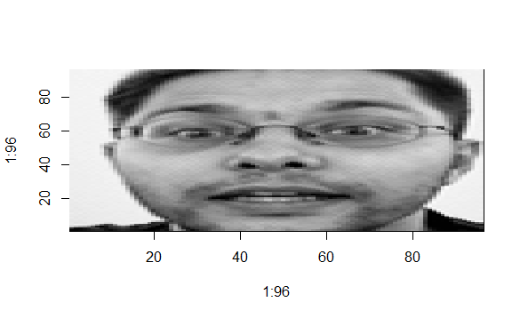
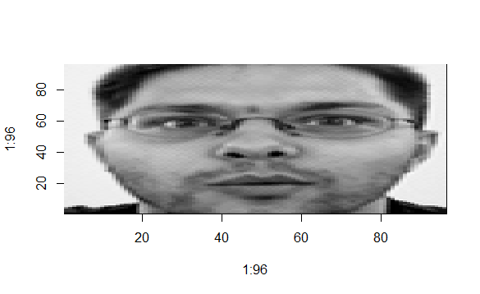
2nd test and corresponding train
